Project Design Phase
Solution Architecture

Date | 23 September 2026
Team ID | AI-WW-01
Project Name | AI Weather Wise
Maximum Marks | 4 Marks

Solution Architecture:
AI Weather Wise uses a layered architecture that connects users, a web interface, a backend service, weather-data sources and an AI analysis module. The architecture goals are to:
- ● Collect current and forecast weather information from reliable weather-data sources.
- ● Process weather data through the backend and AI analysis module to identify useful patterns and conditions.
- ● Provide location-based forecasts, risk information, recommendations and weather alerts through a simple interface.
- ● Support scalable development by separating the user interface, backend, weather-data layer and AI services.

Example - AI Weather Wise Solution Architecture Diagram:
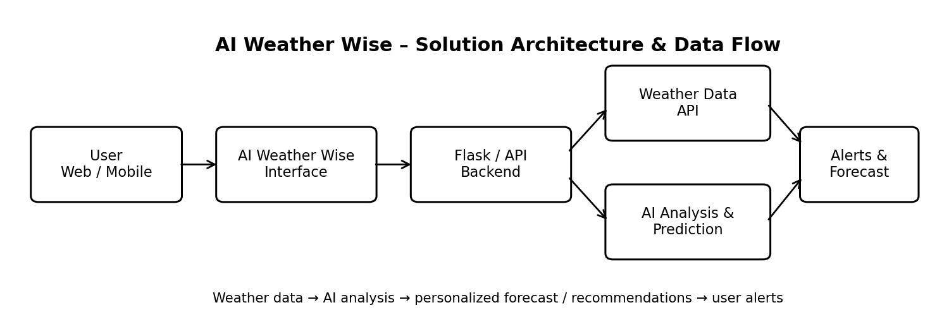

Figure 1: Architecture and data flow of the AI Weather Wise application
Reference: Open-Meteo weather data platform – https://open-meteo.com/

